1. admin creates a new repository on github called **animals**.

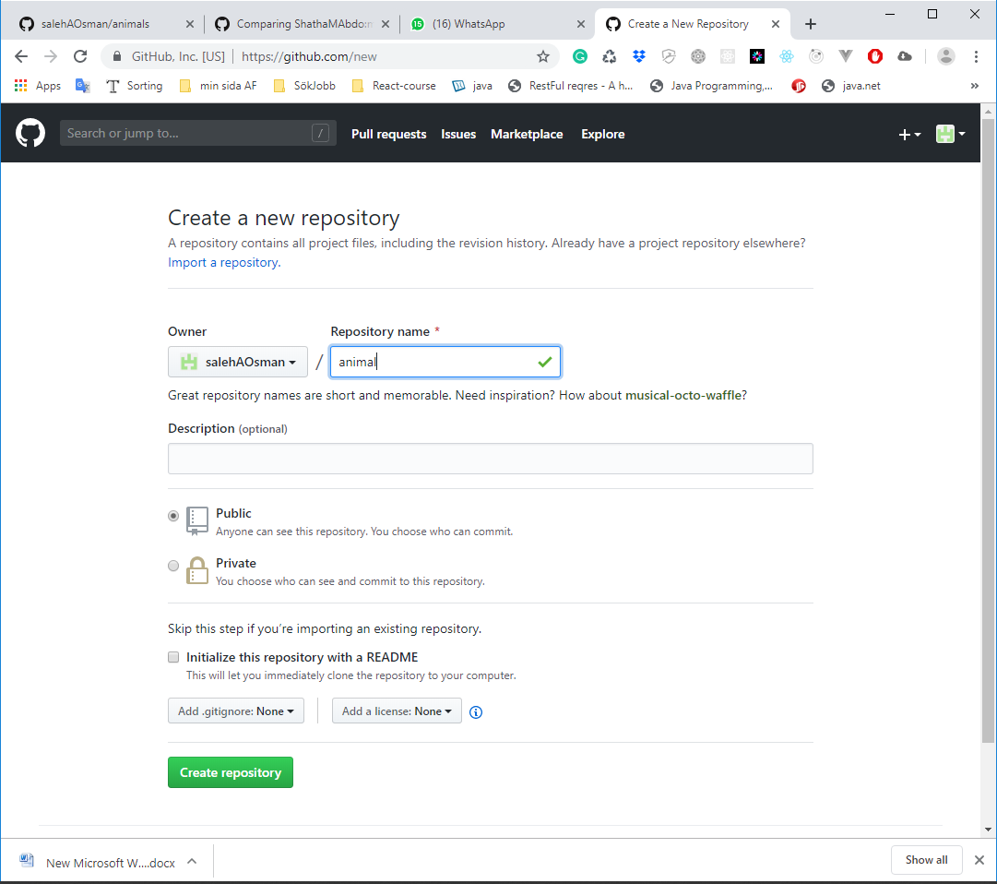

1. admin adds a file called “zoo.txt” with some animals generally found in a zoo.

Create directory in desktop “adminGit”

Right click on “adminGit” select Git Bash here to open git bash in same path

**$ mkdir animals** 🡪 create directory

**$ cd animals** 🡪 get inside it to let it repo

**$git init** 🡪 it has been now transformed from directory to be repository to check that, It has to display **(Master)** beside the same command line

To create a file

**$touch zoo.txt**

**$ ls** 🡪 to check it

**$ echo "Tiger" > zoo.txt** 🡪 to add for first time info_ to file

**$ code zoo.txt** 🡪 to open file by Visual Studio app and see info_

**$** **echo** **"Deer" >> zoo.txt** 🡪 adding info_ to file

**$** **echo** **"Rabbit" >> zoo.txt** 🡪 adding info_ to file

1. admin commits and pushes the changes (in master branch).

**$ git status 🡪** It will display those down

1. On branch master
2. No commits yet
3. Untracked files:
4. (use "git add <file>..." to include in what will be committed)
5. zoo.txt
6. nothing added to commit but untracked files present (use "git add" to track)

**$ git commit -m"added few info_ to file zoo.txt"**

[master (root-commit) 61ef2f9] added few info_ to file zoo.txt

1 file changed, 3 insertions(+)

create mode 100644 zoo.txt

**$ git remote –**v 🡪 It will display firstly no thing, It is command lets you view connections to other repositories.

**$ git remote add origin https://github.com/salehA74Osman/animals.git**

I get [**https://github.com/salehA74Osman/animals.git**](https://github.com/salehA74Osman/animals.git)

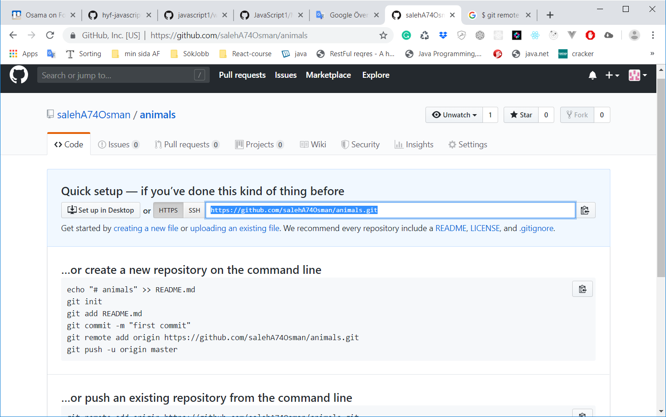

Now wil check connection remotely by GitHub by command down

**$ git remote –**v

origin https://github.com/salehA74Osman/animals.git (fetch)

origin https://github.com/salehA74Osman/animals.git (push)

we have one repository ready in GiutHub

to push

**$ git push -u origin master**

Enumerating objects: 8, done.

Counting objects: 100% (8/8), done.

Delta compression using up to 8 threads

Compressing objects: 100% (3/3), done.

Writing objects: 100% (5/5), 477 bytes | 477.00 KiB/s, done.

Total 5 (delta 0), reused 0 (delta 0)

To https://github.com/salehAOsman/foocoding.git

b361b19..a08e966 master -> master

Branch 'master' set up to track remote branch 'master' from 'origin'.

1. user forks the repository created by admin and bring it to their machine (covered during classwork).

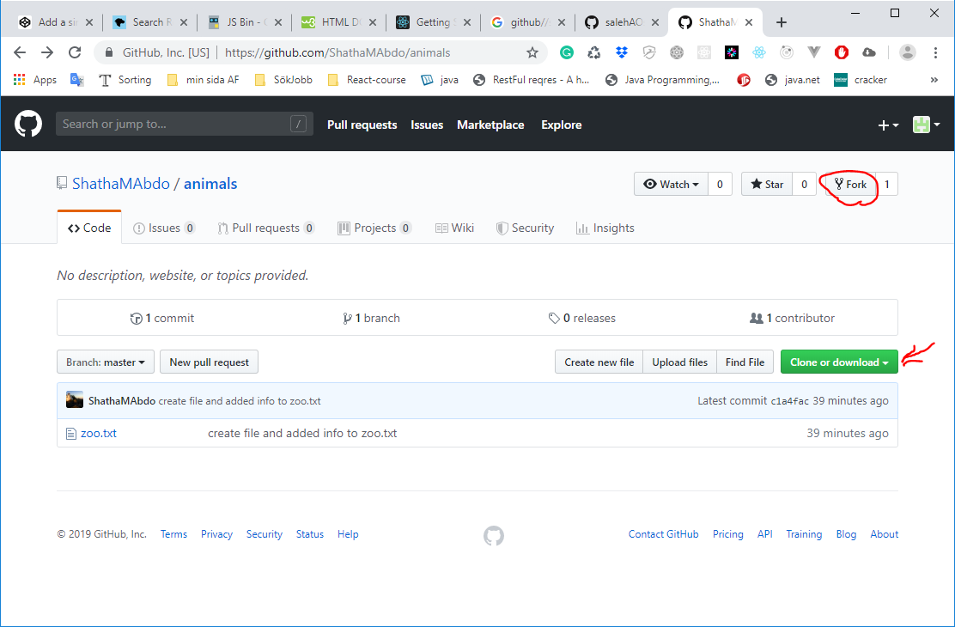

By using clone I will have copy of project in my local repository in my specific path

Go to my directory animals that I clone it by

**$ cd animals**

Now I can modifier my copy of project

1. user makes a new branch called user-dev.

Before make branch we can check branches by

**$ git branch**

**\* master**

We have just one default branch “*master” name

Create a branch from tag in Git:

**$ git branch user-dev**

Now again check

**$ git branch**

**\* master**

**user-dev**

Now we have two branches

We will select “user-dev” by

**$ git checkout user-dev**

**Switched to branch 'user-dev'**

**saleh@LAPTOP-82E9LO9M MINGW64 ~/foocoding/javascript/week1/animals** (user-dev)

OR by One command line $ git checkout -b **<branch_name>**

After creating the new local branch from the current branch and push it to the remote Git repository (create remote branch in Git):

**$ git push -u origin user-dev**

Total 0 (delta 0), reused 0 (delta 0)

remote:

remote: Create a pull request for 'user-dev' on GitHub by visiting:

remote: https://github.com/salehAOsman/animals/pull/new/user-dev

remote:

To https://github.com/salehAOsman/animals.git

* [new branch] user-dev -> user-dev

Branch 'user-dev' set up to track remote branch 'user-dev' from 'origin'.

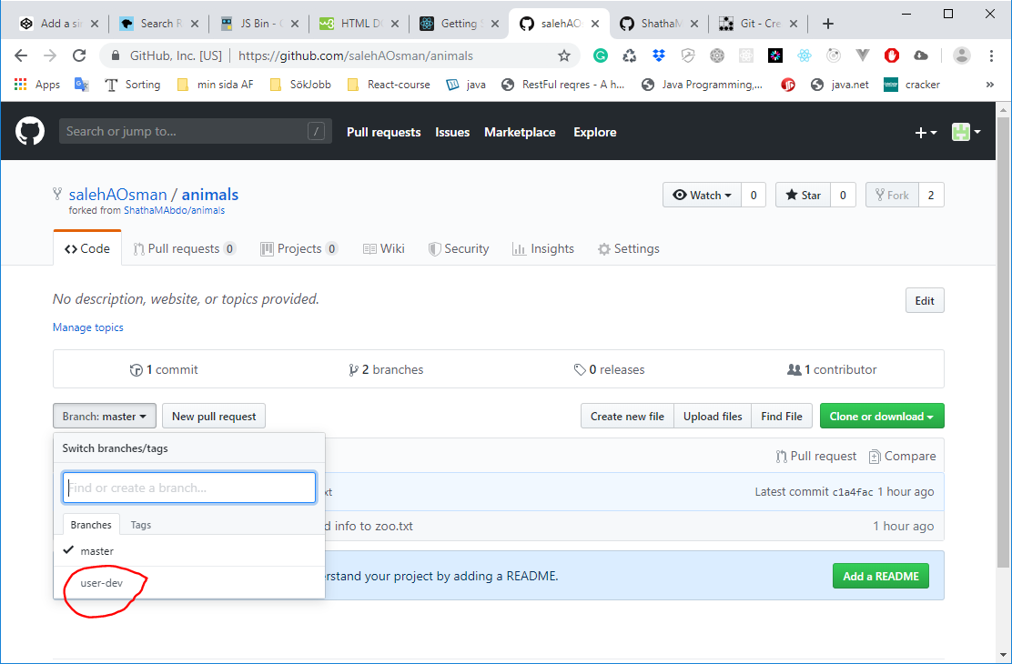

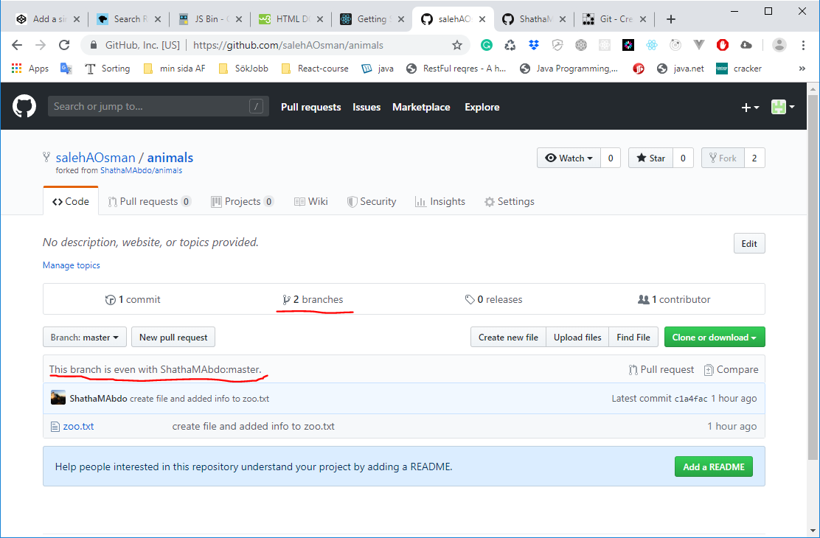

1. user adds another file called “pets.txt” with some animals generally found in a home.

Before we do

**$ git status**

On branch user-dev

Your branch is up to date with 'origin/user-dev'.

nothing to commit, working tree clean

we create pets.txt file and add a few info in it

**$ touch pets.txt**

**$ echo "Dog"> pets.txt**

**$ echo "Cat">> pets.txt**

**$ echo "Bird">> pets.txt**

1. user commits and pushes his branch to remote.

**$ git add .**

**$ git commit -m"create file pets.txt and added few info in it"**

[user-dev 1e9e7d1] create file pets.txt and added few info in it

1 file changed, 3 insertions(+)

create mode 100644 pets.txt

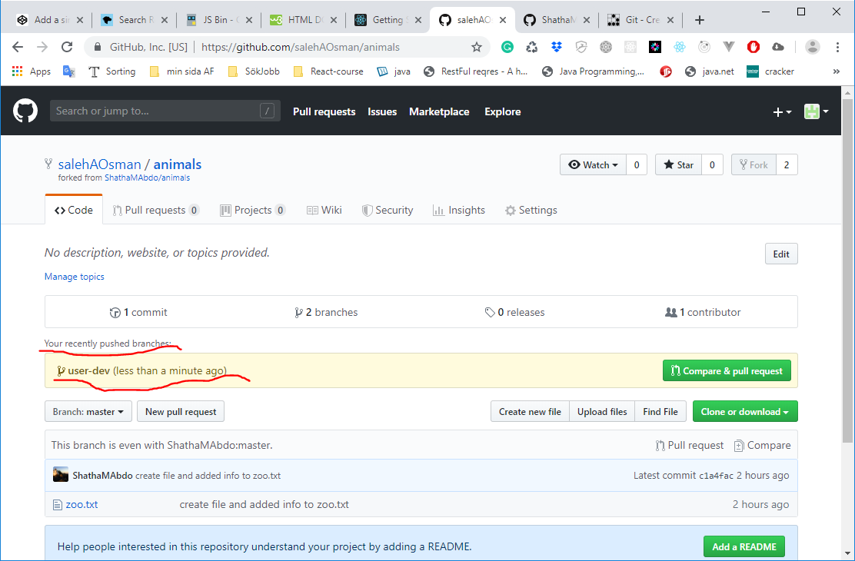

**$ git push -u origin user-dev**

Enumerating objects: 4, done.

Counting objects: 100% (4/4), done.

Delta compression using up to 8 threads

Compressing objects: 100% (2/2), done.

Writing objects: 100% (3/3), 303 bytes | 303.00 KiB/s, done.

Total 3 (delta 0), reused 0 (delta 0)

To https://github.com/salehAOsman/animals.git

c1a4fac..1e9e7d1 user-dev -> user-dev

Branch 'user-dev' set up to track remote branch 'user-dev' from 'origin'.

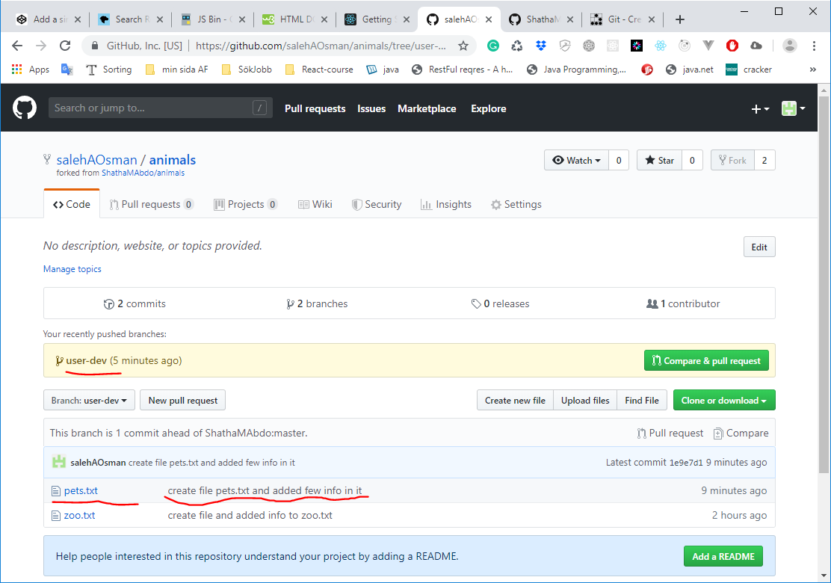

Now we have modifier in my gitHub

1. user creates a pull request(PR) to merge changes from user's *user-dev* branch to admin's *master* branch.

**$ git merge user-dev**

1. Updating c1a4fac..1e9e7d1
2. Fast-forward
3. pets.txt | 3 +++
4. 1 file changed, 3 insertions(+)
5. create mode 100644 pets.txt

Now do this

**$ git status**

On branch master

Your branch is ahead of 'origin/master' by 1 commit.

(use "git push" to publish your local commits)

nothing to commit, working tree clean

so we will push as it is

**$ git push -u origin master**

Total 0 (delta 0), reused 0 (delta 0)

To https://github.com/salehAOsman/animals.git

c1a4fac..1e9e7d1 master -> master

Branch 'master' set up to track remote branch 'master' from 'origin'.

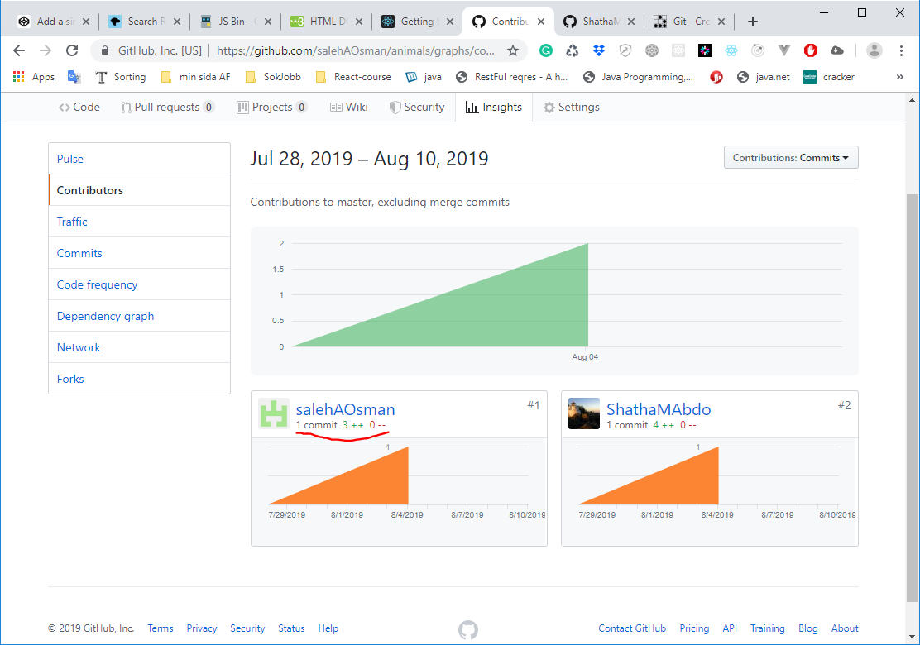

1. admin reviews the pull request and approves and merges changes

my job will be in my GitHub as user , it is not in Admin side

I go to “Pull requests” 🡪 New pull request the we see down

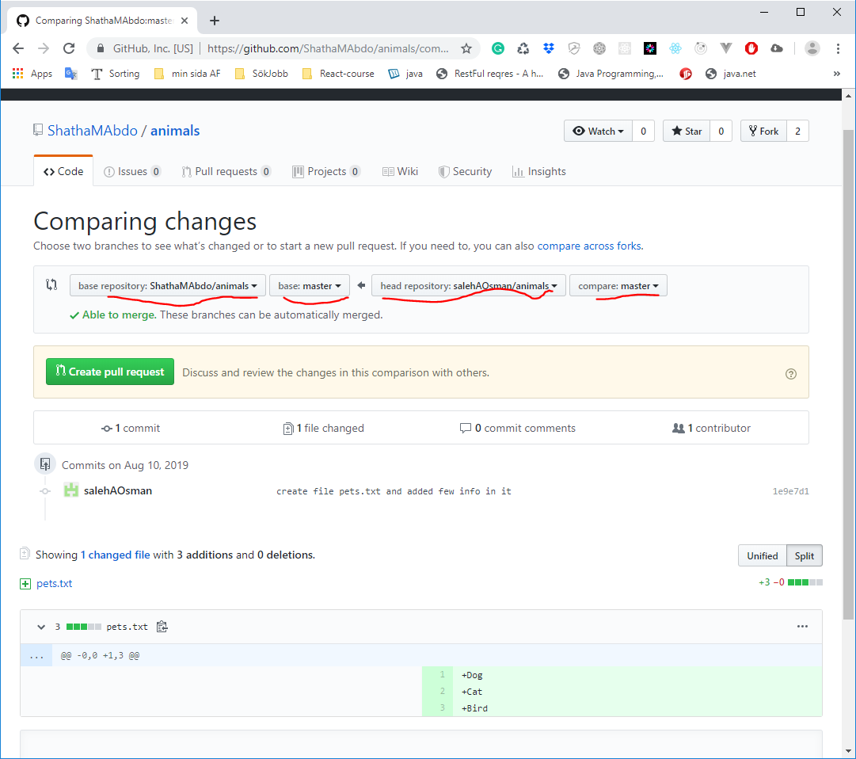

then click Create pull request

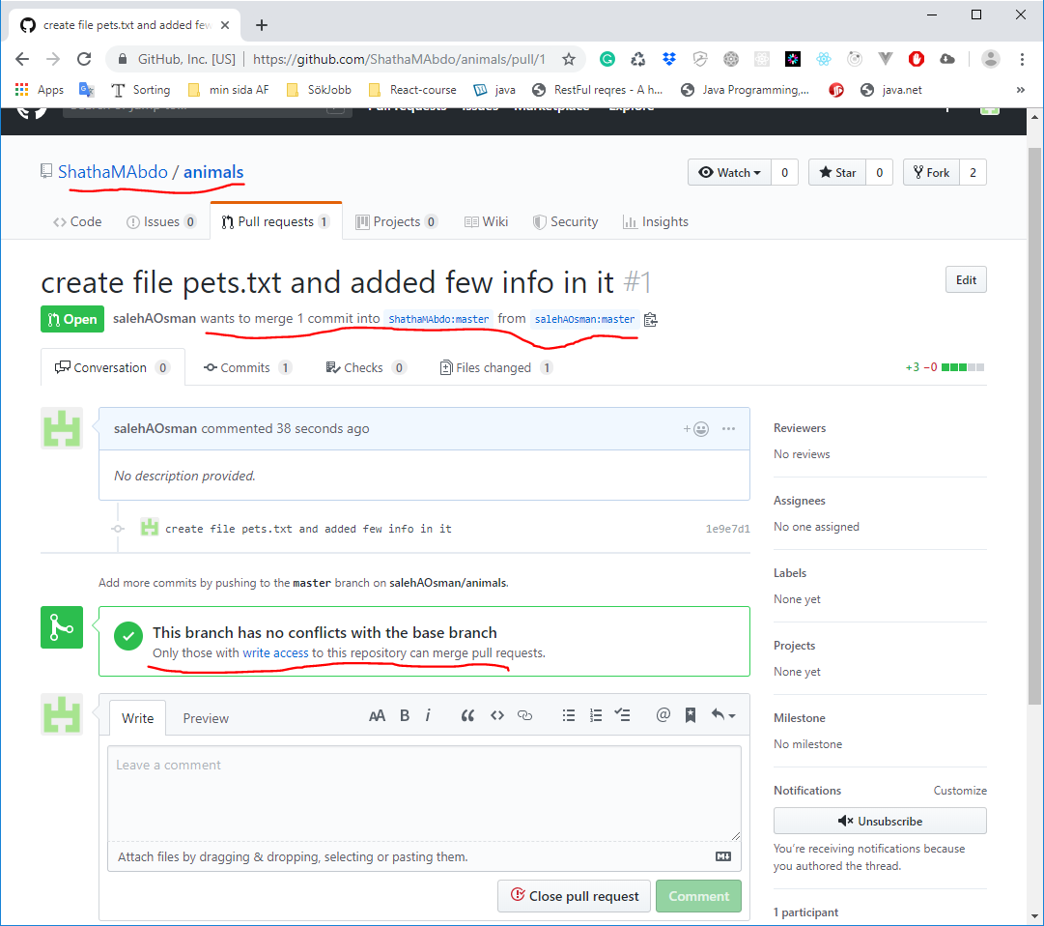

Then click Close pull request to be closed

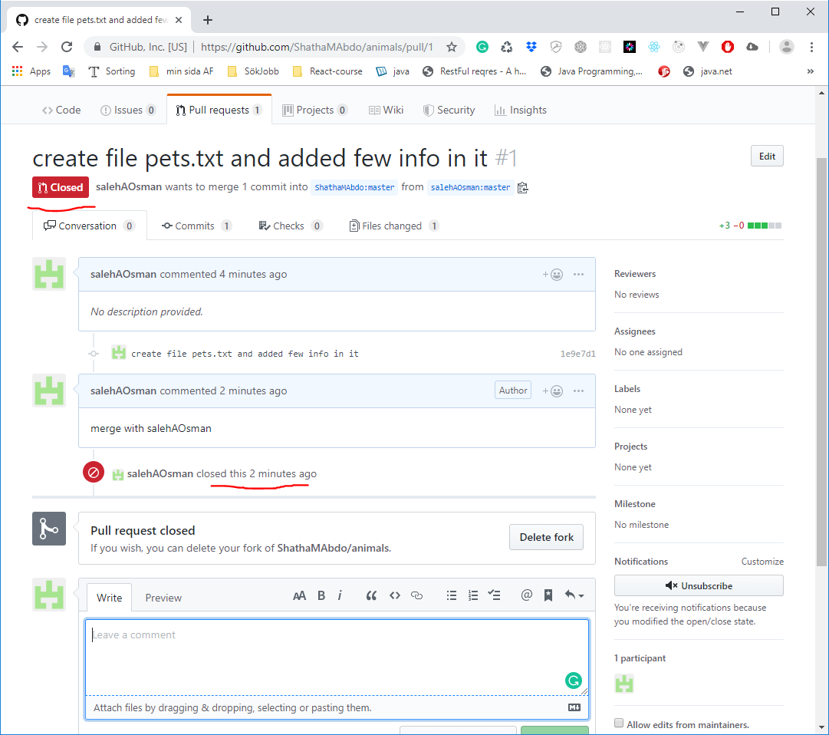

Finally write commit then click commit

